Understanding Movement Variability of Simplistic Gestures Using an Inertial Sensor

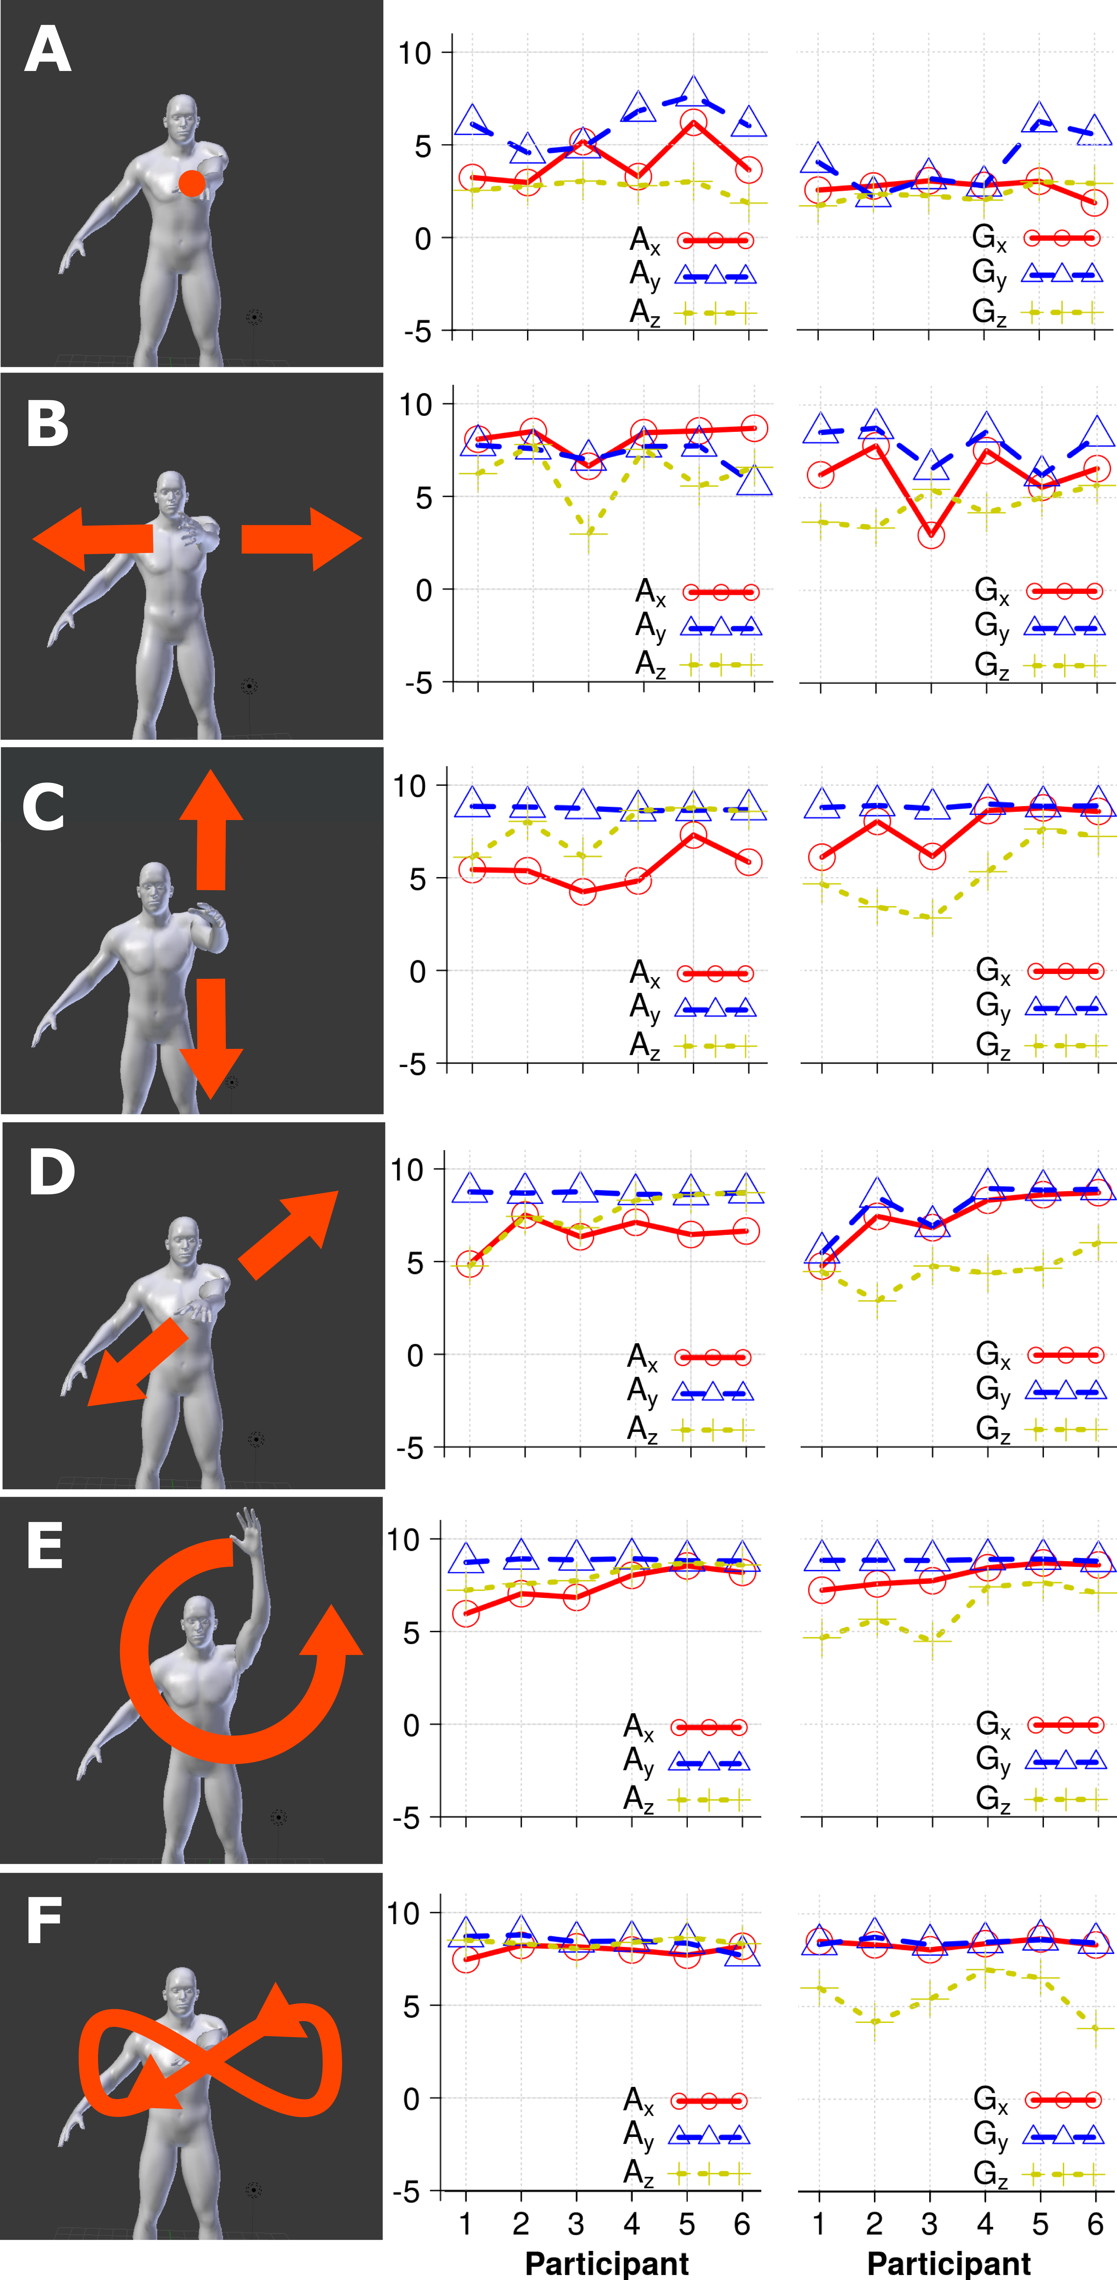

Figure 1. The first column shows the six gestures ((A) static, (B) horizontal, (C) vertical, (D) diagonal, (E) circular and (F) eight shape). The second and third columns present the cumulative energy (accelerometer and gyropscope) for each movement performed by each participant. The data are presented as trend-lines across the participants.

*Please do not modify this text block until you receive explicit instructions.*

Permission to make digital or hard copies of all or part of this work for personal or classroom use is granted without fee provided that copies are not made or distributed for profit or commercial advantage and that copies bear this notice and the full citation on the first page. Copyrights for components of this work owned by others than the author(s) must be honored. Abstracting with credit is permitted. To copy otherwise, or republish, to post on servers or to redistribute to lists, requires prior specific permission and/or a fee. Request permissions from [Permissions@acm.org](mailto:Permissions@acm.org).

*CONF '22,* Jan 1 - Dec 31 2022, Authorberg.

Copyright is held by the owner/author(s). Publication rights licensed to ACM. ACM 978-1-xxxx-yyyy-z/zz/zz…$zz.00.

unique doi string will go here

# Abstract

Miguel Xochicale

University of Birmingham

Birmingham, B15 2TT, UK

map479@bham.ac.uk

Chris Baber

University of Birmingham

Birmingham, B15 2TT, UK

c.baber@bham.ac.uk

Mourad Oussalah

University of Oulu

Oulu, 90014, Finland

moussala@ee.oulu.fi

We present a preliminary experiment to understand the movement variability of six simple movements. Six participants, wearing inertial measurement units on their wrist, repeated performed six actions. The data collected were analysed using time-delay embedding theorem PCA and the percentage of cumulative energy to characterise variability in these movements. The analysis demonstrates how movement variability can be described using different approaches. Such analysis can be useful in diagnosing performance in rehabilitation applications.

# Author Keywords

Time delay embedding; activity recognition; dimensionality reduction; phase space reconstruction

# ACM Classification Keywords

I.5 Pattern Recognition: general; G.3 Probability and statics: statistical computing, time series analysis

# Introduction

Variability is an inherent characteristic of human movement [1] and could provide useful diagnostic information in activity recognition, e.g. in terms of detecting changes in the way in which activities are performed over the course of training, practice or rehabilitation. Movement variability is, however, a common problem in activity recognition. For instance, users usually perform the same action slightly differently trial by trial. One approach would be to remove variability by normalizing the data so that the movements conform to defined models. Another is to find a way to preserve the variability in the movement while also supporting activity recognition. For these reason we are interested in the analysis of the variability of simple movement that can give insight into understanding variably between individuals and between repetitions of the same movement. Variability is presented when users interact with displays. For instance, Zaiţi et al. [2] explored kinematic variations of leap gestures such as gesture volume, gesture length, finger-to-palm distance and articulation speed. We therefore consider that the freedom that wearable sensors (inertial sensors) offer is ideal for both comfortable and unconstrained interaction with displays.

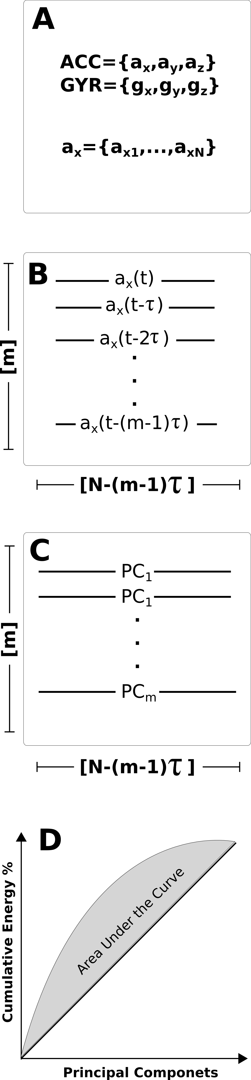

Figure 2. Framework representation for statistical representation of the variably: (A) raw data from inertial sensors, (B) Time-delay embedding, (C) PCA and (D) percentage of cumulative energy.

Figure 1 In this image, the cats are tesselated to save space. You, too, can save space by placing images in the sidebar. Images should have captions and be within the boundaries of the text box on Page 2. Photo CC-BY jofish on Flickr.

# Framework for the experiment

To analyse the data from six individuals who performed each action for 20 seconds, we use the time-delay embedding and PCA techniques. To do this, the raw data is collected from triaxial accelerometer and triaxial gyroscope sensors. Then, the time-series, for instance, ***ax***, with a length of ***N*** samples is used to obtain the time-delay embedded matrix, ***E****{* ***ax*** *}* [3], with *m* rows and *N − (m − 1)τ* columns. PCA algorithm is applied to obtain, via eigenvalues (*λ1,…,λm*) of eigenvectors (*v1,…,vm*), the principal components (*PC1,…,PCm*) of the time-delay embedded phase space. Finally, the percentage of cumulative energy is computed [4] (Fig. 2).

# Conclusion and Future work

Although the Time-delay embedding technique is subject to different values of embedded parameters (*m* and *τ*) according to the length and complexity of the time-series, the technique is useful to statistically present the inherent features of variability between 6 participants for six different gestures (Fig. 1). Those results cannot be obtained from the PCA alone. Appreciating variability in human activity can not only provide useful diagnostic information but also offers an approach to considering the manner in which people interact with pervasive displays.  For example, each of the gestures described in this study could be performed in ways which signifies different states of enthusiasm, boredom, tiredness or confusion. Rather than generating individual models of each of the actions performed in each of these states, being able to detect the variability in the action could help determine how the user is interacting with the display, possibly allowing the displays to respond accordingly.

# References

1. K. M. Newell. a. D. M. Corcos, Variability and motor control, United States of America: Human Kinetics Publishers, 1993.
2. I.-A. Zaiţi, P. Ştefan-Gheorghe and R.-D. Vatavu, "On free-hand TV control: experimental results on user-elicited gestures with Leap Motion," *Personal and Ubiquitous Computing,* vol. 19, pp. 821--838, 2015.
3. J. Frank, S. Mannor and D. Precup, "Activity and Gait Recognition with Time-Delay Embeddings," in *Proceedings of the Twenty-Fourth AAAI Conference on Artificial Intelligence*, 2010.
4. N. Y. Hammerla, T. Plötz, P. Andras and P. Olivier, "Assessing motor performance with pca," in *Proceedings of the IWFAR*, 2011.